Introduction to Functions 1

Types of Mapping

Mappings can be described as one-one, one-many, many-one or many-many

One-one mappings
Each x value corresponds with exactly one y value, and vice versa
Example
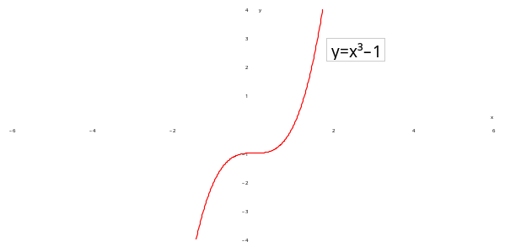

One-many mappings
Each x value corresponds to more than one y value, but each y value corresponds to only one x value
Example
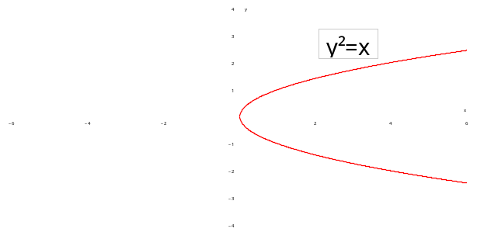

Many-one mappings
Each x value corresponds to only one y value, but each y value corresponds to more than one x value
Example
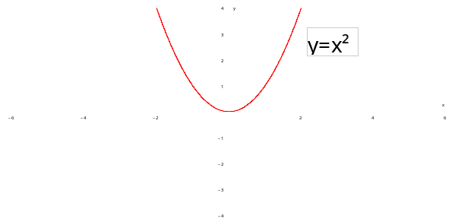

Many-many mappings
Each x value corresponds to more than one y value, and each y value corresponds to more than one x-value
Example
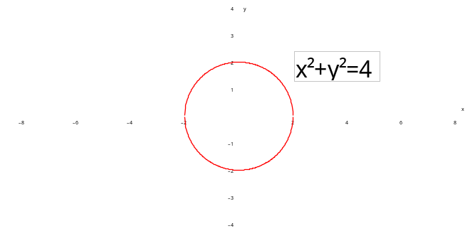
Introduction to Functions 2

A function is a mapping that is either one-one or many-one

Example
Identifying the mappings given as one-one, many-one, one-many or many-many, and decide whether they are functions or not

(a) 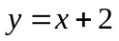

(b) 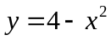

(c) 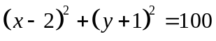

Domain and Range of a Function

When a function is defined, as well as being told the equation, you must also be told the set of x values that are to be inputted into this equation. This is called the DOMAIN of the function, and is part of the definition of the function.
Once you know the possible x values, you can work out the corresponding y values; this is called the RANGE of the function. The range will be different, for the same equation with a different domain

Example
By sketching the graph of , work out the range of the following functions

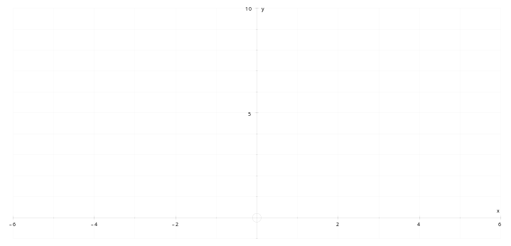

(a) 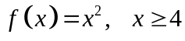

(b) 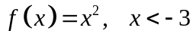

(c) 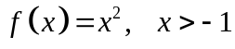

(d) 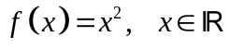

Introduction to Functions 3

Question 1

Place the following mappings in the table below
(a) 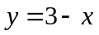 (b) 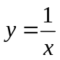 (c) 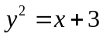 (d) 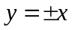
(e) 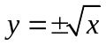 (f) 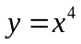 (g) 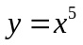 (h) 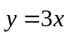

FUNCTIONS |  | NOT FUNCTIONS
One-one | Many-one | One-Many | Many-Many

Question 2

Match the functions in the left-hand column with the ranges in the right-hand column, and write your answers in the space provided below

 | Function and Domain |  | Range
A | 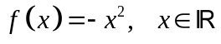 | 1 | 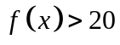
B | 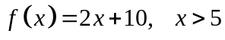 | 2 | 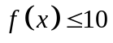
C | 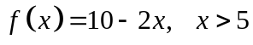 | 3 | 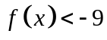
D | 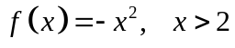 | 4 | 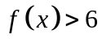
E | 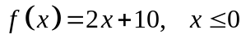 | 5 | 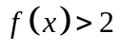
F | 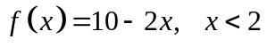 | 6 | 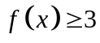
G | 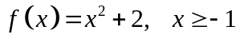 | 7 | 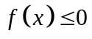
H | 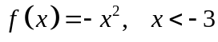 | 8 | 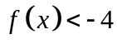
I | 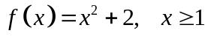 | 9 | 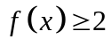
J | 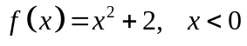 | 10 | 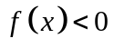

A | B | C | D | E | F | G | H | I | J

Question 3

(a) The function 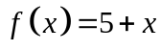 has a range of 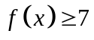. What is its domain?

(b) The function 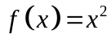 has a range of 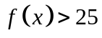. State two possible domains for the function

Solutions to Introduction to Functions 3

Q1
- one-one
- one-one
- one-many
- many-many
- one-many
- many-one
- one-one
- one-one

Q2

A | B | C | D | E | F | G | H | I | J
7 | 1 | 10 | 8 | 2 | 4 | 9 | 3 | 6 | 5

Q3

(a) 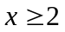
(b) 